pp

Matthew 3: 16-17
¹³ Then Jesus came from Galilee to the Jordan to be baptized by John. ¹⁴ But John tried to deter him, saying, “I need to be baptized by you, and do you come to me?”
¹⁵ Jesus replied, “Let it be so now; it is proper for us to do this to fulfill all righteousness.” Then John consented.
¹⁶ As soon as Jesus was baptized, he went up out of the water. At that moment heaven was opened, and he saw the Spirit of God descending like a dove and alighting on him. ¹⁷ And a voice from heaven said, “This is my Son, whom I love; with him I am well pleased.”
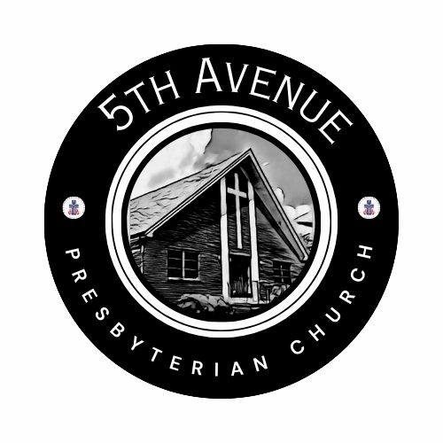
FORMING FAITH BIBLE STUDY
Mondays at 12pm
NEW Zoom ID: 848 1620 9379; NEW Passcode: 538538

5th AVENUE CONGREGATIONAL WORKSHOP
Saturday, January 31, 10am-2pm (lunch provided)
Participate in-person or on Zoom
Topics include:
- The Role of the “Church”
- The Myths of a “Successful” Church
- Social Media Presence
- Imagination/Vision/Planning
- “Passing the Plate”
- What’s Next? Honoring the Past/Looking Towards a Future

Whether you live in Roanoke or a distance away; whether you
participate in the life of 5th Avenue in-person or utilizing Zoom,
this workshop seeks your voice and invites you to assist in
imagining what our congregation can be. Join us!

Fifth Avenue Presbyterian Church
301 Patton Avenue NW, Roanoke VA 24016
https://www.5thavepresbychurchroanoke.com ZOOM ID: 893 2944 7595 PASSCODE: 856037
Sunday, January 11, 2026
We count it a joy that you would share with us today!
May the Lord bless you and keep you,
May the face of the Lord shine upon you and be gracious to you,
May the Lord turn to you and give you peace…

Blessed Break (Let us greet one another in the name of Jesus)
We Share God’s Word
Scripture … Matthew 3: 13-17 … Nickey Wright
Reflect in Words … Beth Durodoye
Reflect in Music… Kimari Spangler
Message … I Need You … Rev. Vernie L. Bolden, Jr

We Respond
Respond in Song … Rev Ellen Woodworth
Celebration of Giving
Giving Prayer O Lord, we are reminded of the Apostle Paul when addressing the Corinthian Church, “…each one must give as he has decided in his heart, not reluctantly or under compulsion, for God loves a cheerful giver…” O Lord, thank you guiding us to be cheerful. Cheerful in the giving of our time and our talents, cheerful in the offering of our resources, and cheerful in the giving of our love. AMEN.
Affirm Our Faith 1 John 1: 5-7 ⁵ This is the message we have heard from the Lord and declare to you: God is light; in the Lord there is no darkness at all. ⁶ If we claim to have fellowship with God, yet walk in the darkness, we lie and do not live out the truth. ⁷ But if we walk in the light, as the Lord is in the light, we have fellowship with one another, and the blood of Jesus, God’s Son, purifies us from all sin.

We Tell the Good News
Go in Peace … Kimari Spangler
Benediction … Rev. Vernie L. Bolden, Jr

Our Prayer List
Jon Barton, Rhonda Hale, Jim Slaughter, Joe Loving, Jr, Thom Witting, Gabriela Rangel, Greg Beliveau, Geri Tankersly, Lucy Glymph, Jawaad Saunders, Virginia Robinson

Fifth Avenue Presbyterian Church
Sunday, January 11, 2026

We Gather
Musical Prelude … Kimari Spangler (2)
Greetings/Call to Worship … … Lisa Robinson As we gather to worship and praise our Lord, even as we rejoice in those around us who have borne witness to our tears and laughter, and held us through tragedy and grief, we are reminded that the people (and places) who are fading from our presence does not negate what once was. O Lord, remind us of the beauty of the things that last only a season, yet comfort us with your everlasting presence as we live into your will of what is to come. Together we say, thank you, hallelujah, and AMEN.
Gathering in Music … Kimari Spangler

We Call Upon the Lord
Invitation from Scripture (1 Thess: 5: 16-18) Rev. Bob Fiedler
¹⁶ Rejoice always, ¹⁷ pray continually, ¹⁸ give thanks in all circumstances; for this is God’s will for you in Christ Jesus.

Invitation in Song … Joyce Bolden

Prayers of the People … Rev. Ellen Woodworth

The Lord’s Prayer Our Father, who art in heaven, hallowed be thy name, the kingdom come, thy will be done, on earth as it is in heaven. Give us this day our daily bread and forgive us our debts as we forgive our debtors. Lead us not into temptation, but deliver us from evil, for thine is the kingdom and the power and the glory forever. AMEN.

Gloria Patri … Kimari Spangler

