Mark 5: 25-34
²⁵ And a woman was there who had been subject to bleeding for twelve years. ²⁶ She had suffered a great deal under the care of many doctors and had spent all she had, yet instead of getting better she grew worse. ²⁷ When she heard about Jesus, she came up behind him in the crowd and touched his cloak, ²⁸ because she thought, “If I just touch his clothes, I will be healed.” ²⁹ Immediately her bleeding stopped, and she felt in her body that she was freed from her suffering.
³⁰ At once Jesus realized that power had gone out from him. He turned around in the crowd and asked, “Who touched my clothes?”
³¹ “You see the people crowding against you,” his disciples answered, “and yet you can ask, ‘Who touched me?’”
³² But Jesus kept looking around to see who had done it. ³³ Then the woman, knowing what had happened to her, came and fell at his feet and, trembling with fear, told him the whole truth. ³⁴ He said to her, “Daughter, your faith has healed you. Go in peace and be freed from your suffering.”

Our Prayer List
Jon Barton, Rhonda Hale, Jim Slaughter, Joe Loving, Jr, Thom Witting, Gabriela Rangel, Geri Tankersly, Ja’Land & Denny Robinson, Robert & Katrine Cole, Jawaad Saunders, Kimberly Wyatt, Virginia Robinson, Ruth and Philip Claytor

FORMING FAITH BIBLE STUDY
Mondays @ 12pm
Zoom ID: 848 1620 9379 Passcode: 538638

REMINDER: 5th Avenue safely and securely accepts gifts of offering and giving through mail, in-person, or our website: https://www.5thavepresbychurchroanoke.com

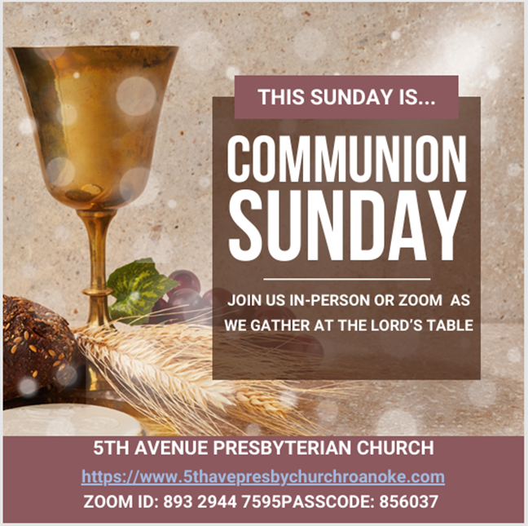
Fifth Avenue Presbyterian Church
301 Patton Avenue NW, Roanoke VA 24016

https://www.5thavepresbychurchroanoke.com
ZOOM ID: 893 2944 7595 PASSCODE: 856037
Sunday, March 1, 2026
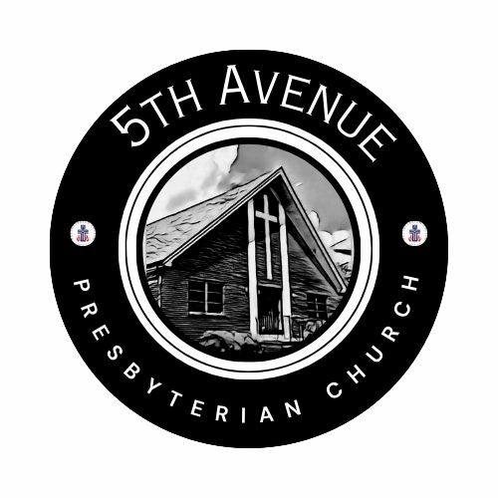
We count it a joy that you would share with us today!
May the Lord bless you and keep you,
May the face of the Lord shine upon you and be gracious to you,
May the Lord turn to you and give you peace…

Fifth Avenue Presbyterian Church
Sunday, March 1, 2026
Second Sunday of Lent
We Gather

Musical Prelude … Avery Bolden (2)

Greetings/Call to Worship … Cathy Keith
Today is a day to sing praises to our God! Even during the cold and darkness, The Lord continually blesses us, each day with the warmth of love. Let us know that our Lord will never leave us, nor forsake us, let our hearts rejoice and let our voices shout praises to God, for the Lord is great and worthy to be praised. AMEN.
We Call Upon the Lord

Call to Confession … Rev. Bob Fiedler
Gracious God, we come before you, acknowledging our need for forgiveness and grace. You call us to trust in you, but instead we are fearful as we hesitate to follow your lead. We loudly attempt to justify our actions and words, though quietly we know they are not what you require. We struggle to understand the new life possible in Christ yet fail to reach for him. O Lord, we acknowledge we cannot do this by ourselves.
Silent Confession

Assurance of Pardon
Let our spirit find assurance and rest in the song of the Psalmist (121)
I lift up my eyes to the hills, from where will my help come? ² My help comes from the Lord, who made heaven and earth. ³ The Lord will not let your foot be moved; the one who keeps you will not slumber.
⁵ The Lord is your keeper; the Lord is your shade at our right hand.
With humble hearts full of hope, we are grateful to know that in Jesus Christ, we are forgiven

Prayers of the People
The Lord’s Prayer Our Father, who art in heaven, hallowed be thy name, the kingdom come, thy will be done, on earth as it is in heaven. Give us this day our daily bread and forgive us our debts as we forgive our debtors. Lead us not into temptation, but deliver us from evil, for thine is the kingdom and the power and the glory forever. AMEN.

Gloria Patri … Rev. Ellen Woodworth

Blessed Break (Let us greet one another in the name of Jesus)

We Share God’s Word

Scripture … Mark 5: 25-34

Reflect in Song … Avery Bolden

Message … Finding Relief… Rev. Vernie L. Bolden, Jr

We Respond

INVITATION TO THE TABLE

Song of Invitation … Rev. Ellen Woodworth

Meditation

The Bread and Cup

Prayer of Thanksgiving

Affirm Our Faith (Romans 8: 35-39)
³⁵ Who shall separate us from the love of Christ? Shall trouble or hardship or persecution or famine or nakedness or danger or sword…? ³⁷ No, in all these things we are more than conquerors through the one who loved us. ³⁸ For I am convinced that neither death nor life, neither angels nor demons, neither the present nor the future, nor any powers, ³⁹ neither height nor depth, nor anything else in all creation, will be able to separate us from the love of God that is in Christ Jesus our Lord.
We Tell the Good News
Go in Peace … Joyce Bolden

Benediction … Rev. Vernie L. Bolden, Jr

