pp
Exodus 3: 7-12
⁷ The Lord said, “I have indeed seen the misery of my people in Egypt. I have heard them crying out because of their slave drivers, and I am concerned about their suffering. ⁸ So I have come down to rescue them from the hand of the Egyptians and to bring them up out of that land into a good and spacious land, a land flowing with milk and honey—the home of the Canaanites, Hittites, Amorites, Perizzites, Hivites and Jebusites. ⁹ And now the cry of the Israelites has reached me, and I have seen the way the Egyptians are oppressing them. ¹⁰ So now, go. I am sending you to Pharaoh to bring my people the Israelites out of Egypt.”
¹¹ But Moses said to God, “Who am I that I should go to Pharaoh and bring the Israelites out of Egypt?”
¹² And God said, “I will be with you. And this will be the sign to you that it is I who have sent you: When you have brought the people out of Egypt, you will worship God on this mountain.”

FORMING FAITH BIBLE STUDY
Mondays at 12pm
NO BIBLE STUDY on MON JAN 19

5th AVENUE CONGREGATIONAL WORKSHOP
Saturday, January 31, 10am-2pm (lunch provided)
Participate in-person or on Zoom
Zoom ID: 873 2808 1122 Passcode: 299931
Topics include:
The Role of the “Church” / The Myths of a “Successful” Church
Social Media Presence/ Imagination / “Passing the Plate”
What’s Next? Honoring the Past/Looking Towards a Future

Whether you live in Roanoke, a distance away, participate in the life of 5th Avenue in-person or utilizing Zoom, this workshop seeks your voice and invites you to assist in imagining what our congregation can be. Join us!

PC(USA) CHURCHWIDE FILM STUDY
Evicting the American Dream
Mondays in February (FEB 2, 9, 16, 23)
7:30pm-8:45pm ET
More details to come

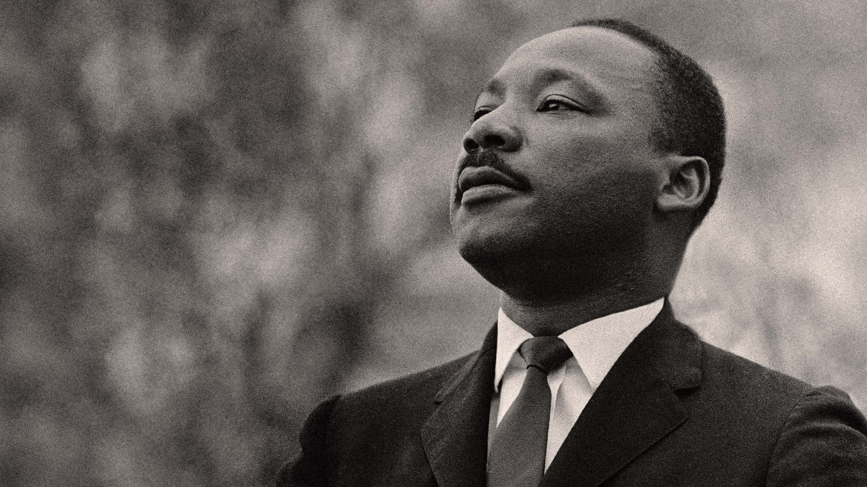
Fifth Avenue Presbyterian Church
301 Patton Avenue NW, Roanoke VA 24016
https://www.5thavepresbychurchroanoke.com ZOOM ID: 893 2944 7595 PASSCODE: 856037
Sunday, January 18, 2026
We count it a joy that you would share with us today!
May the Lord bless you and keep you,
May the face of the Lord shine upon you and be gracious to you,
May the Lord turn to you and give you peace…

Blessed Break (Let us greet one another in the name of Jesus)
We Share God’s Word
Scripture … Exodus 3: 7-12
Reflect in Words … Michael Blankenship
Reflect in Music… Kimari Spangler
Message … I Am Here … Rev. Vernie L. Bolden, Jr

We Respond
Respond in Song … Rev Ellen Woodworth
Affirm Our Faith 1 John 1: 5-7 ⁵ This is the message we have heard from the Lord and declare to you: God is light; in the Lord there is no darkness at all. ⁶ If we claim to have fellowship with God, yet walk in the darkness, we lie and do not live out the truth. ⁷ But if we walk in the light, as the Lord is in the light, we have fellowship with one another, and the blood of Jesus, God’s Son, purifies us from all sin.

Celebration of Giving
Giving Prayer O Lord, we are reminded of the Apostle Paul when addressing the Corinthian Church, “…each one must give as he has decided in his heart, not reluctantly or under compulsion, for God loves a cheerful giver…” O Lord, thank you guiding us to be cheerful. Cheerful in the giving of our time and our talents, cheerful in the offering of our resources, and cheerful in the giving of our love. AMEN.

We Tell the Good News
Go in Peace … Kimari Spangler
Benediction … Rev. Vernie L. Bolden, Jr

Our Prayer List
Jon Barton, Rhonda Hale, Jim Slaughter, Joe Loving, Jr, Thom Witting, Gabriela Rangel, Greg Beliveau, Geri Tankersly, Lucy Glymph, Jawaad Saunders, Virginia Robinson

Fifth Avenue Presbyterian Church
Sunday, January 18, 2026

We Gather
Musical Prelude … Kimari Spangler (2)
Gathering Scripture … Psalm 129: 1-4 … Martin Rangel
“They have greatly oppressed me from my youth,” let Israel say; ² “they have greatly oppressed me from my youth, but they have not gained the victory over me. ³ Plowmen have plowed my back and made their furrows long. ⁴ But the Lord is righteous; the Lord has cut me free from the cords of the wicked.”
Greetings/Call to Worship (from C.A. Riley) … Lisa Robinson INHALE: God, how long? EXHALE: Justice is coming
INHALE: We will not feel guilty for hope EXHALE: We accept nothing less than freedom
INHALE: I will not make excuses for unrighteousness
EXHALE: Consequence is Holy
BREATHE: Thank you, hallelujah, and AMEN

We Call Upon the Lord
Invitation in Song … Joyce Bolden

Prayers of the People … Rev. Ellen Woodworth

The Lord’s Prayer Our Father, who art in heaven, hallowed be thy name, the kingdom come, thy will be done, on earth as it is in heaven. Give us this day our daily bread and forgive us our debts as we forgive our debtors. Lead us not into temptation, but deliver us from evil, for thine is the kingdom and the power and the glory forever. AMEN.

Gloria Patri … Kimari Spangler

