
Fifth Avenue Presbyterian Church
301 Patton Avenue NW Roanoke VA 24016
https://www.5thavepresbychurchroanoke.com ZOOM ID: 893 2944 7595 PASSCODE: 856037
Sunday, October 26, 2025

Luke 18: 9-14 (Common English Bible)

⁹ Jesus told this parable to certain people who had convinced themselves that they were righteous and who looked on everyone else with disgust: ¹⁰ “Two people went up to the temple to pray. One was a Pharisee and the other a tax collector. ¹¹ The Pharisee stood and prayed about himself with these words, ‘God, I thank you that I’m not like everyone else—crooks, evildoers, adulterers—or even like this tax collector. ¹² I fast twice a week. I give a tenth of everything I receive.’ ¹³ But the tax collector stood at a distance. He wouldn’t even lift his eyes to look toward heaven. Rather, he struck his chest and said, ‘God, show mercy to me, a sinner.’ ¹⁴ I tell you, this person went down to his home justified rather than the Pharisee. All who lift themselves up will be brought low, and those who make themselves low will be lifted up.”

1 Thessalonians 5:12-24, 28 (CEB)
¹² Brothers and sisters, we ask you to respect those who are working with you, leading you, and instructing you. ¹³ Think of them highly with love because of their work. Live in peace with each other. ¹⁴ Brothers and sisters, we urge you to warn those who are disorderly. Comfort the discouraged. Help the weak. Be patient with everyone. ¹⁵ Make sure no one repays a wrong with a wrong, but always pursue the good for each other and everyone else. ¹⁶ Rejoice always. ¹⁷ Pray continually. ¹⁸ Give thanks in every situation because this is God’s will for you in Christ Jesus. ¹⁹ Don’t suppress the Spirit. ²⁰ Don’t brush off Spirit-inspired messages, ²¹ but examine everything carefully and hang on to what is good. ²² Avoid every kind of evil. ²³ Now, may the God of peace himself cause you to be completely dedicated to him; and may your spirit, soul, and body be kept intact and blameless at our Lord Jesus Christ’s coming. ²⁴ The one who is calling you is faithful and will do this. ²⁸ The grace of our Lord Jesus Christ be with all of you.

BLESSING OF THE ANIMALS (Pets):
SUNDAY, NOV 2, on the front lawn after worship

FORMING FAITH BIBLE STUDY Mondays @ 12pm: Zoom ID: 844 2443 7027 Passcode: 489354

REMINDER
5th Avenue safely and securely accepts gifts of offering and giving through mail, in-person, or our website: https://www.5thavepresbychurchroanoke.com

God has shown you, O mortal, what is good.

And what does the Lord require of you?

To act justly and to love mercy

and to walk humbly with your God.

(Micah 6:8)

We Share God’s Word
Scripture … Luke 18: 9-14; 1 Thessalonians 5: 12-24, 28
Reflect in Song … Avery Bolden
Message … “Better Than That” … Rev. Ellen Woodworth

We Respond
The Congregation Responds in Song
“They’ll Know We are Christians by Our Love” (Red - #284)
Celebration of Giving
Giving Prayer
Lord God, all that we are and all that we have are your gifts to us. In gratitude and joy for your gracious love, we return to you our time, our talents, our lives in service;
by the power of the Holy Spirit, through Jesus Christ, our Lord. Amen.
Affirm Our Faith (Luke 10: 25-28) ²⁵ On one occasion an expert in the law stood up to test Jesus. “Teacher,” he asked, “what must I do to inherit eternal life?” ²⁶ “What is written in the Law?” he replied. “How do you read it?” ²⁷ He answered, “‘Love the Lord your God with all your heart and with all your soul and with all your strength and with all your mind’; and ‘Love your neighbor as yourself.’” ²⁸ “You have answered correctly,” Jesus replied. “Do this and you will live.”

We Tell the Good News

Benediction … Rev. Ellen Woodworth
Go in Peace … Congregation Sings … “Day by Day” x 2 (Red - #55)
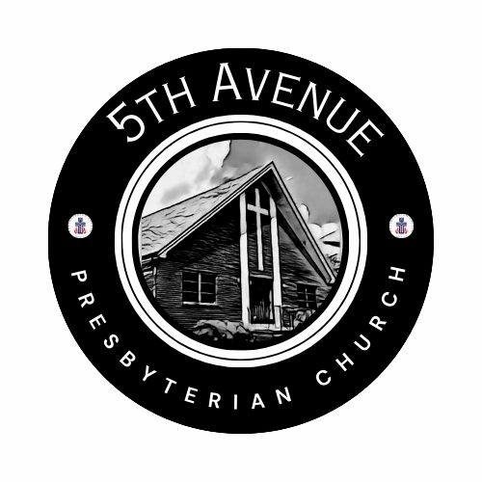
Our Prayer List
Jon Barton, Rhonda Hale, Jim Slaughter, Joe Loving, Jr, Thom Witting, Gabriela Rangel, Greg Beliveau, Geri Tankersly, Lucy Glymph, Camelia Cherry, Carolyn Coleman, Jawaad Saunders, Virginia Robinson

Fifth Avenue Presbyterian Church
Sunday, October 26, 2025

We Gather
Musical Prelude … Kimari Spangler (2)
Scripture Reading … Psalm 84:1-7… Martin Rangel
How lovely is your dwelling place, O LORD of hosts! My soul longs, indeed, it faints, for the courts of the LORD; my heart and my flesh sing for joy to the living God. Even the sparrow finds a home and the swallow a nest for herself, where she may lay her young, at your altars, O LORD of hosts, my King and my God. Happy are those who live in your house, ever singing your praise. Happy are those whose strength is in you, in whose heart are the highways to Zion.

Greetings/Call to Worship … Lisa Robinson
Patient and ever-loving God, we bring you now our lives as they are, our joys and sorrows, our hopes and fears. There are things that are good in us, there are things that are wrong in us, and we look to you for healing and encouragement. Gracious God, help us with your good and kindly Spirit. Inspire our worship and tell us of your love, so that we may share your mercy and receive your peace. Hear our prayers as we say thank you, Hallelujah and AMEN.

We Call Upon the Lord
Invitation in Music … Avery Bolden

Prayers of the People … Rev. Ellen Woodworth
The Lord’s Prayer Our Father, who art in heaven, hallowed be thy name, the kingdom come, thy will be done, on earth as it is in heaven. Give us this day our daily bread and forgive us our debts as we forgive our debtors. Lead us not into temptation, but deliver us from evil, for thine is the kingdom and the power and the glory forever. AMEN.
Gloria Patri … Kimari Spangler
Blessed Break (Let us greet one another in the name of Jesus)

