Matthew 4: 1-11

Then Jesus was led by the Spirit into the wilderness to be tempted by the devil. ² After fasting forty days and forty nights, he was hungry. ³ The tempter came to him and said, “If you are the Son of God, tell these stones to become bread.”
⁴ Jesus answered, “It is written: ‘Man shall not live on bread alone, but on every word that comes from the mouth of God.’”
⁵ Then the devil took him to the holy city and had him stand on the highest point of the temple. ⁶ “If you are the Son of God,” he said, “throw yourself down. For it is written: “‘He will command his angels concerning you, and they will lift you up in their hands, so that you will not strike your foot against a stone.
⁷ Jesus answered him, “It is also written: ‘Do not put the Lord your God to the test.’”
⁸ Again, the devil took him to a very high mountain and showed him all the kingdoms of the world and their splendor. ⁹ “All this I will give you,” he said, “if you will bow down and worship me.”
¹⁰ Jesus said to him, “Away from me, Satan! For it is written: ‘Worship the Lord your God and serve him only.’”
¹¹ Then the devil left him, and angels came and attended him

Our Prayer List
Jon Barton, Rhonda Hale, Jim Slaughter, Joe Loving, Jr, Thom Witting, Gabriela Rangel, Geri Tankersly, Ja’Land & Denny Robinson, Robert & Katrine Cole, Jawaad Saunders, Kimberly Wyatt, Virginia Robinson

BLACK HISTORY LUNCH
Saturday, February 28, pick up @ 11:30-12:30
Lisa Robinson is graciously preparing fried catfish meals for those from 5th Avenue!
Please reach out to Lisa to indicate the time you will come by and pick them up.
Please notice, there is no charge for this Black History Month gift.
Thank you, Lisa and family!

1633 Lonna Drive NW
Roanoke VA 24019
540-278-5120

FORMING FAITH BIBLE STUDY
Mondays @ 12pm
Zoom ID: 848 1620 9379 Passcode: 538638

REMINDER: 5th Avenue safely and securely accepts gifts of offering and giving through mail, in-person, or our website: https://www.5thavepresbychurchroanoke.com

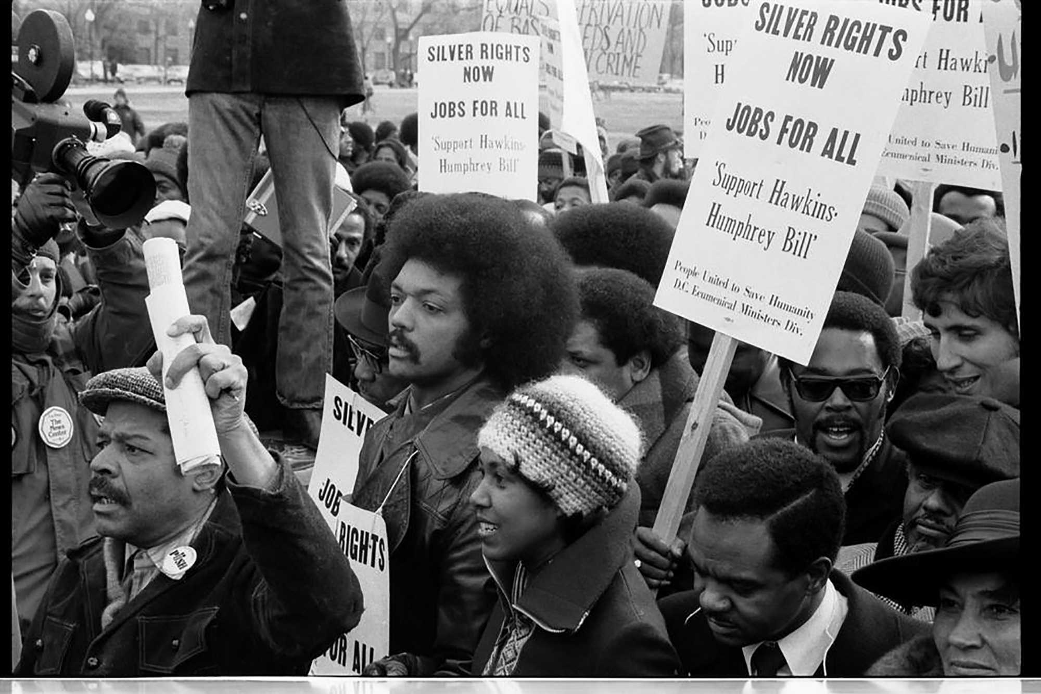
Fifth Avenue Presbyterian Church
301 Patton Avenue NW, Roanoke VA 24016

https://www.5thavepresbychurchroanoke.com
ZOOM ID: 893 2944 7595 PASSCODE: 856037
Sunday, February 22, 2026
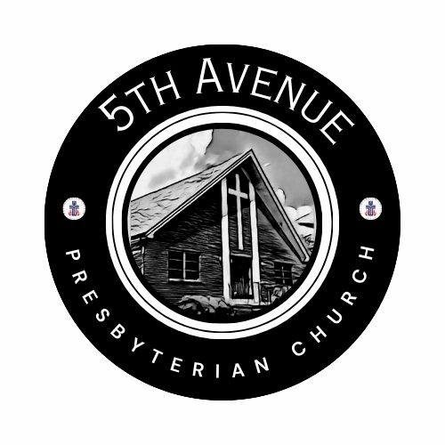
We count it a joy that you would share with us today!
May the Lord bless you and keep you,
May the face of the Lord shine upon you and be gracious to you,
May the Lord turn to you and give you peace…

Celebrate Black History Month

Fifth Avenue Presbyterian Church
Sunday, February 15, 2026
First Sunday of Lent
We Gather

Musical Prelude … Kimari Spangler (2)
Scripture Reading … Joshua 24: 14-15 … Tara Howard
¹⁴ “Now, therefore, revere the Lord and serve God in sincerity and in faithfulness; put away the gods that your ancestors served beyond the River and in Egypt and serve the Lord. ¹⁵ Now if you are unwilling to serve the Lord, choose this day whom you will serve, whether the gods your ancestors served in the region beyond the River, or the gods of the Amorites in whose land you are living, but as for me and my household, we will serve the Lord.”

Greetings/Call to Worship (from Howard Thurman) … Lisa Robinson
There is something in everyone of us that waits, listens for the sound of the genuine in yourself- and if you cannot hear it, you will never find whatever it is for which you search; and if you hear it and then do not follow it, it was better that you had never been born… If you cannot hear the genuine in you, you will all of your life spend days on the ends of strings that somebody else pulls. O Lord, as we gather to worship, we are grateful that you have released us from the strings. Together we say thank you, Hallelujah and AMEN.

We Call Upon the Lord

Invitation in Song … Joyce Bolden

Prayers of the People … Rev. Ellen Woodworth
The Lord’s Prayer Our Father, who art in heaven, hallowed be thy name, the kingdom come, thy will be done, on earth as it is in heaven. Give us this day our daily bread and forgive us our debts as we forgive our debtors. Lead us not into temptation, but deliver us from evil, for thine is the kingdom and the power and the glory forever. AMEN.
Gloria Patri … Kimari Spangler
Blessed Break (Let us greet one another in the name of Jesus)

We Share God’s Word
Scripture … Matthew 4: 1-11 … Brooke Stephens
Reflect in Music … Kimari Spangler
Reflect in Words
Message … I Am Somebody … Rev. Vernie L. Bolden. Jr
We Respond
Respond in Music … Rev. Ellen Woodworth

Celebration of Giving

Giving Prayer O Lord, whatever our task, guide us to do it wholeheartedly:
in teaching, let us give all we have
in speaking, let us be stirred with all we have
in giving, let us cheerfully share
in helping, let us generously contribute to the needs of your people, just as you taught us
spoke to us
shared with us
and filled our deepest need
O Lord, thank you for the blessing of being able to give. AMEN.
Affirm Our Faith (1 Corinthians 13) If I speak in the tongues of men or of angels, but do not have love, I am only a resounding gong or a clanging cymbal. ² If I have the gift of prophecy and can fathom all mysteries and all knowledge, and if I have a faith that can move mountains, but do not have love, I am nothing. ³ If I give all I possess to the poor and give over my body to hardship that I may boast, but do not have love, I gain nothing. ⁴ Love is patient, love is kind. It does not envy, it does not boast, it is not proud. ⁵ It does not dishonor others, it is not self-seeking, it is not easily angered, it keeps no record of wrongs. ⁶ Love does not delight in evil but rejoices with the truth. ⁷ It always protects, always trusts, always hopes, always perseveres… ¹³ And now these three remain: faith, hope and love. But the greatest of these is love.
We Tell the Good News

Go in Peace … Kimari Spangler
Benediction … Rev. Vernie L. Bolden, Jr

