pp
Ephesians 4: 22-25; 5: 1-2
²² You were taught, with regard to your former way of life, to put off your old self, which is being corrupted by its deceitful desires; ²³ to be made new in the attitude of your minds; ²⁴ and to put on the new self, created to be like God in true righteousness and holiness.
²⁵ Therefore each of you must put off falsehood and speak truthfully to your neighbor, for we are all members of one body…
5: ¹ Follow God’s example, therefore, as dearly loved children ² and walk in the way of love, just as Christ loved us and gave himself up for us as a fragrant offering and sacrifice to God.
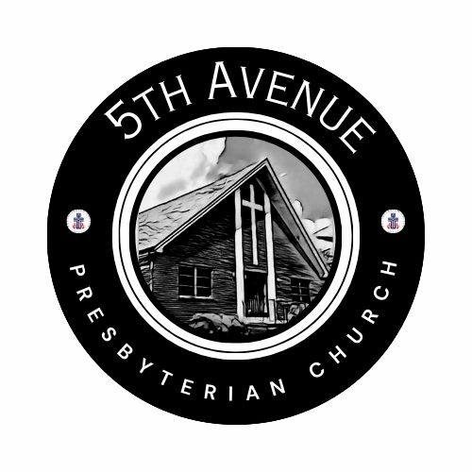
Our Prayer List
Jon Barton, Rhonda Hale, Jim Slaughter, Joe Loving, Jr, Thom Witting, Gabriela Rangel, Greg Beliveau, Geri Tankersly, Lucy Glymph, Jawaad Saunders, Virginia Robinson
* * *

FORMING FAITH BIBLE STUDY Mondays @ 12pm: Zoom ID: 844 2443 7027 Passcode: 489354

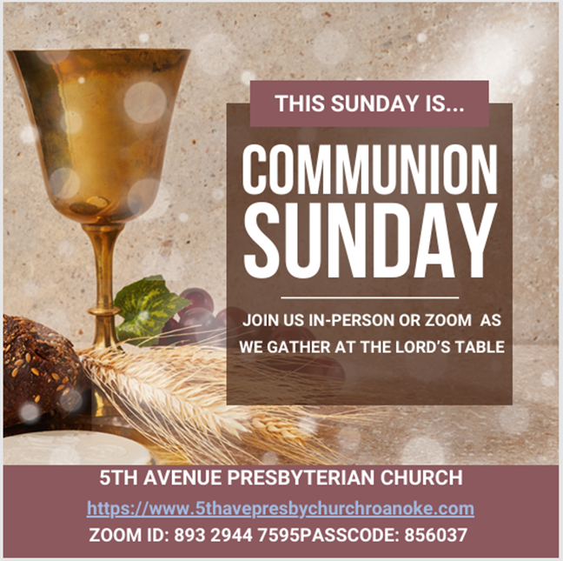
Fifth Avenue Presbyterian Church
301 Patton Avenue NW, Roanoke VA 24016
https://www.5thavepresbychurchroanoke.com ZOOM ID: 893 2944 7595 PASSCODE: 856037
Sunday, January 4, 2026
We count it a joy that you would share with us today!
May the Lord bless you and keep you,
May the face of the Lord shine upon you and be gracious to you,
May the Lord turn to you and give you peace…
Happy New Year

Giving Prayer O Lord, we are reminded of the Apostle Paul when addressing the Corinthian Church, “…each one must give as he has decided in his heart, not reluctantly or under compulsion, for God loves a cheerful giver…” O Lord, thank you guiding us to be cheerful. Cheerful in the giving of our time and our talents, cheerful in the offering of our resources, and cheerful in the giving of our love. AMEN.

The Lord’s Prayer Our Father, who art in heaven, hallowed be thy name, the kingdom come, thy will be done, on earth as it is in heaven. Give us this day our daily bread and forgive us our debts as we forgive our debtors. Lead us not into temptation, but deliver us from evil, for thine is the kingdom and the power and the glory forever. AMEN.
Gloria Patri … Rev. Ellen Woodworth

Blessed Break (Let us greet one another in the name of Jesus)

We Share God’s Word
Scripture … Ephesians 4: 22-25; 5: 1-2 … Beth Durodoye
Reflect in Song … Avery Bolden
Message … This Time … Rev. Vernie L. Bolden, Jr

We Respond

INVITATION TO THE TABLE
Song of Invitation … Rev. Ellen Woodworth
Scripture … Isaiah 18: 16-19
Meditation
The Bread and Cup (Let Us Break Bread … Rev. Ellen Woodworth)
Prayer of Thanksgiving

Affirm Our Faith (1 John 3: 5-10) ⁵ This is the message we have heard from the Lord and declare to you: God is light; in the Lord there is no darkness at all. ⁶ If we claim to have fellowship with God, yet walk in the darkness, we lie and do not live out the truth. ⁷ But if we walk in the light, as the Lord is in the light, we have fellowship with one another, and the blood of Jesus, God’s Son, purifies us from all sin. ⁸ If we claim to be without sin, we deceive ourselves and the truth is not in us. ⁹ If we confess our sins, The Lord is faithful and just and will forgive us our sins and purify us from all unrighteousness. ¹⁰ If we claim we have not sinned, we make God out to be a liar, and the word is not in us.

We Tell the Good News
Go in Peace … Rev. Ellen Woodworth
Benediction … Rev. Vernie L. Bolden, Jr

Fifth Avenue Presbyterian Church
Sunday, January 4, 2026
We Gather
Musical Prelude … Avery Bolden (2)
Greetings/Call to Worship … Psalm 119: 145-148 … Brooke Stephens
¹⁴⁵ I call with all my heart; answer me, Lord,
and I will obey your decrees.
¹⁴⁶ I call out to you; save me
and I will keep your statutes.
¹⁴⁷ I rise before dawn and cry for help;
I have put my hope in your word.
¹⁴⁸ My eyes stay open through the watches of the night,
that I may meditate on your promises.

We Call Upon the Lord
Call to Confession (from C.A. Riley) … Rev. Dusty Fiedler
At the dawning of this new year, we confess all the ways we have suppressed dignity and limited liberation: we have not pursued justice and repair for the excluded and the oppressed; we have neglected and dismissed those with less power than us; we have not loved others considered less than us; and we have dismissed our elders and ignored the youth. O Lord, in our sorrow and with troubled souls, we ask that you examine our lives as we present ourselves to you. AMEN.
Silent Confession
Assurance of Pardon
Let our spirit find assurance and rest in the song of the Psalmist (59)
¹⁶ But I will sing of your strength,
in the morning I will sing of your love;
for you are my fortress,
my refuge in times of trouble.
¹⁷ You are my strength, I sing praise to you;
you, God, are my fortress,
my God on whom I can rely…
With humble hearts full of joy and thanksgiving, we are grateful to know that in Jesus Christ, we are forgiven
Prayers of the People

