pp
1 Corinthians 1:18
¹⁸ For the message about the cross is foolishness to those who are perishing, but to us who are being saved it is the power of God.
______________________________________________________________________________________________________________________________________________________________________________________________________________________________________________________________________________
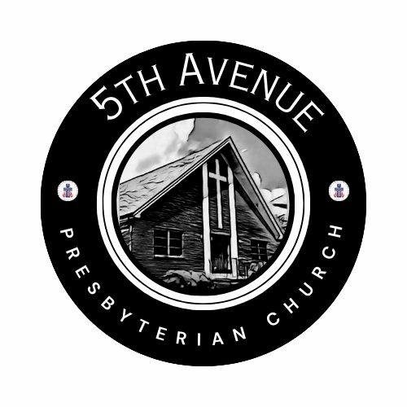
Our Prayer List
Jon Barton, Rhonda Hale, Jim Slaughter, Joe Loving, Jr, Thom Witting, Gabriela Rangel, Greg Beliveau, Geri Tankersly, Robert and Katrine Coles, Jawaad Saunders, Virginia Robinson
* * *
CONGREGATIONAL WORKSHOP
Saturday, February 14, 10am-12:30pm
Participate in-person or via Zoom
Zoom ID: 873 2808 1122 Passcode: 299931

FORMING FAITH BIBLE STUDY Mondays @ 12pm: Zoom ID: 844 2443 7027 Passcode: 489354

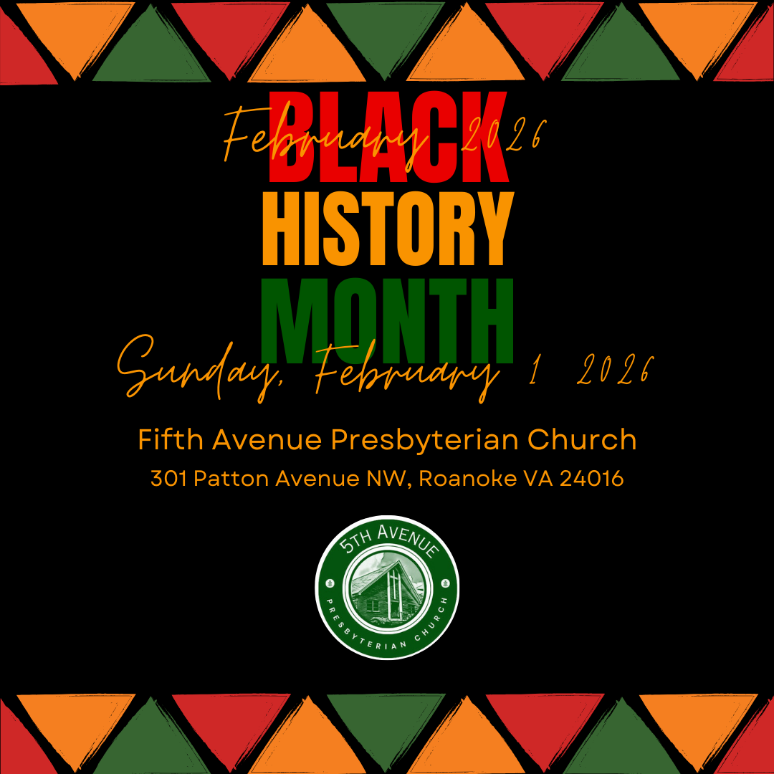
https://www.5thavepresbychurchroanoke.com ZOOM ID: 893 2944 7595 PASSCODE: 856037
Communion Sunday
We count it a joy that you would share with us today!
May the Lord bless you and keep you,
May the face of the Lord shine upon you and be gracious to you,
May the Lord turn to you and give you peace…

Giving Prayer O Lord, we are reminded of the Apostle Paul when addressing the Corinthian Church, “…each one must give as he has decided in his heart, not reluctantly or under compulsion, for God loves a cheerful giver…” O Lord, thank you for guiding us to be cheerful. Cheerful in the giving of our time and our talents, cheerful in the offering of our resources, and cheerful in the giving of our love. AMEN.

The Lord’s Prayer Our Father, who art in heaven, hallowed be thy name, the kingdom come, thy will be done, on earth as it is in heaven. Give us this day our daily bread and forgive us our debts as we forgive our debtors. Lead us not into temptation, but deliver us from evil, for thine is the kingdom and the power and the glory forever. AMEN.
Gloria Patri … Rev. Ellen Woodworth

Blessed Break (Let us greet one another in the name of Jesus)

We Share God’s Word
Scripture … 1 Corinthians 1: 18
Reflect in Song … Avery Bolden
Message … Foolish Messages … Rev. Vernie L. Bolden, Jr

We Respond

INVITATION TO THE TABLE
Song of Invitation … Rev. Ellen Woodworth
Words of Invitation … The Giver … Beth Durodoye
Meditation
The Bread and Cup
Prayer of Thanksgiving

Affirm Our Faith (Romans 8: 35-39)
³⁵ Who shall separate us from the love of Christ? Shall trouble or hardship or persecution or famine or nakedness or danger or sword…? ³⁷ No, in all these things we are more than conquerors through the one who loved us. ³⁸ For I am convinced that neither death nor life, neither angels nor demons, neither the present nor the future, nor any powers, ³⁹ neither height nor depth, nor anything else in all creation, will be able to separate us from the love of God that is in Christ Jesus our Lord.
We Tell the Good News
Go in Peace … Joyce Bolden
Benediction … Rev. Vernie L. Bolden, Jr

Fifth Avenue Presbyterian Church
Sunday, February 1, 2026
We Gather
Musical Prelude … Avery Bolden (2)
Greetings/Scripture (Micah 6: 7-8) … Nickey Wright
⁷ Will the Lord be pleased with thousands of rams, with ten thousand rivers of olive oil? Shall I offer my firstborn for my transgression, the fruit of my body for the sin of my soul?
⁸ He has shown you, O mortal, what is good. And what does the Lord require of you? To act justly and to love mercy
and to walk humbly with your God… thank you, Hallelujah, and AMEN.

We Call Upon the Lord
Call to Confession
God has told us what is good, what is required: Do justice. Love kindness. Walk humbly with God.
These commands are so simple, yet we know we have not always followed them. O Lord, we fail to do what is right and instead, we pursue evil, we do not speak the truth and treat kindness as a character flaw. Even when we try our best to be faithful, still we turn away from you. O Lord, forgive us, accept us, and redeem us, that we may seek to do what you call good. AMEN
Silent Confession
Assurance of Pardon
Let our spirit find assurance and rest in the song of the Psalmist (55)
⁶ I said, “Oh, that I had the wings of a dove!
I would fly away and be at rest.
⁷ I would flee far away
and stay in the desert;
⁸ I would hurry to my place of shelter,
far from the tempest and storm.”
With humble hearts full of hope, we are grateful to know that in Jesus Christ, we are forgiven
Prayers of the People

