Ephesians 5: 15-20
¹⁵ Be very careful, then, how you live—not as unwise but as wise, ¹⁶ making the most of every opportunity, because the days are evil. ¹⁷ Therefore do not be foolish but understand what the Lord’s will is. ¹⁸ Do not get drunk on wine, which leads to debauchery. Instead, be filled with the Spirit, ¹⁹ speaking to one another with psalms, hymns, and songs from the Spirit. Sing and make music from your heart to the Lord, ²⁰ always giving thanks to God the Father for everything, in the name of our Lord Jesus Christ.
SEASON of ADVENT: SUNDAY, NOVEMBER 30 – WEDNESDAY, DECEMBER 24

5th SUNDAYS with 5th AVENUE:
SUNDAY, NOVEMBER 30: Raleigh Court Health & Rehab Center 2pm
1527 Grandin Road

CHURCH SWAP:
SUNDAY, DECEMBER 7 5th Avenue will share in the 11am worship
Unitarian Universalist Church of Roanoke
2015 Grandin Road

LIGHTING of the CHRISTMAS TREE: SUNDAY, DECEMBER 14 (sanctuary)

SESSION MEETING: SUNDAY, DECEMBER 14: following the worship service

BLUE NIGHT WORSHIP:
SUNDAY, DECEMBER 18 @ 6pm
In-person and ZOOM ID: 832 9678 1799 Passcode: 128626

FORMING FAITH BIBLE STUDY:
Mondays @ 12pm: Zoom ID: 844 2443 7027 Passcode: 489354

REMINDER: 5th Avenue safely and securely accepts gifts of offering and giving through mail, in-person, or our website: https://www.5thavepresbychurchroanoke.com



Happy Thanksgiving!

Fifth Avenue Presbyterian Church
301 Patton Avenue NW, Roanoke VA 24016
Sunday, November 23, 2025
We count it a joy that you would share with us today!
May the Lord bless you and keep you,
May the face of the Lord shine upon you and be gracious to you,
May the Lord turn to you and give you peace…

Fifth Avenue Presbyterian Church, 301 Patton Avenue NW, Roanoke VA 24016 https://www.5thavepresbychurchroanoke.com ZOOM ID: 893 2944 7595 PASSCODE: 856037

Fifth Avenue Presbyterian Church
Sunday, November 23, 2025
***
We Gather

Musical Prelude … Kimari Spangler (2)
Scripture Reading … Psalm 103: 1-5 … Nickey Wright
Bless the Lord, O my soul, and all that is within me, bless God’s holy name. Bless the Lord, O my soul, and do not forget all God’s benefits—who forgives all your sins, who heals all your diseases, who redeems your life from the Pit, who crowns you with steadfast love and mercy, who satisfies you with good as long as you live so that your youth is renewed like the eagle’s.

Greetings/Call to Worship … Lisa Robinson We have gathered to give thanks for all we have received from the Lord’s good hands. We come together and declare that this is the day the Lord has made, and we will rejoice and be glad in it. Some of us are sitting in the church sanctuary, some of us are gathered together by the miracle of ZOOM technology. O Lord, we have all gathered to say Thank you, Hallelujah, Amen! for your love endures forever.
We Call Upon the Lord

Invitation in Music … Rev. Ellen Woodworth

Prayers of the People … Rev. Dusty Kenyon Fiedler
The Lord’s Prayer Our Father, who art in heaven, hallowed be thy name, the kingdom come, thy will be done, on earth as it is in heaven. Give us this day our daily bread and forgive us our debts as we forgive our debtors. Lead us not into temptation, but deliver us from evil, for thine is the kingdom and the power and the glory forever. AMEN.
Gloria Patri … Kimari Spangler
Blessed Break (Let us greet one another in the name of Jesus)

We Share God’s Word
Scripture … Ephesians 5: 15-20
Reflect in Music … Kimari Spangler
Message … Blessing Received: Now What? … Rev. Bob Fiedler
We Respond
Respond in Song … Joyce Bolden

Celebration of Giving

Giving Prayer O Lord, we are reminded of the Apostle Paul when addressing the Corinthian Church, “…each one must give as he has decided in his heart, not reluctantly or under compulsion, for God loves a cheerful giver…” O Lord, thank you guiding us to be cheerful. Cheerful in the giving of our time and our talents, cheerful in the offering of our resources, and cheerful in the giving of our love. AMEN.
Affirm Our Faith John 3: 16-17 (First Nations Version; an Indigenous translation) 16 The Great Spirit loves this world of human beings so deeply they gave us their Son- the only Son who fully represents them. All who trusts in him and his way will not come to a bad end but will have the life of the world to come that never fades away, full of beauty and harmony. 17 Creator did not send their Son to decide against the people of this world, but to set them free from the worthless ways of the world.
We Tell the Good News

Go in Peace … Rev. Ellen Woodworth

Benediction … Rev. Bob Fiedler
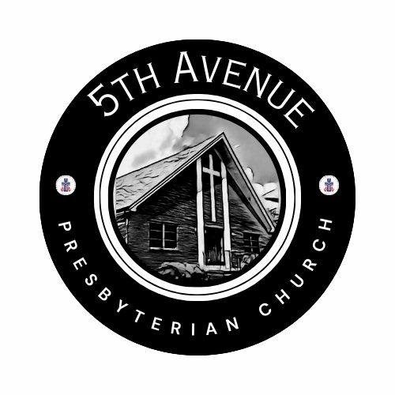
Our Prayer List
Jon Barton, Rhonda Hale, Jim Slaughter, Joe Loving, Jr, Thom Witting, Gabriela Rangel, Greg Beliveau, Geri Tankersly, Lucy Glymph, Jawaad Saunders, Virginia Robinson

