Luke 19: 1-10

Jesus entered Jericho and was passing through. ² A man was there by the name of Zacchaeus; he was a chief tax collector and was wealthy. ³ He wanted to see who Jesus was, but because he was short, he could not see over the crowd. ⁴ So he ran ahead and climbed a sycamore-fig tree to see him, since Jesus was coming that way.
⁵ When Jesus reached the spot, he looked up and said to him, “Zacchaeus, come down immediately. I must stay at your house today.” ⁶ So he came down at once and welcomed him gladly.
⁷ All the people saw this and began to mutter, “He has gone to be the guest of a sinner.”
⁸ But Zacchaeus stood up and said to the Lord, “Look, Lord! Here and now, I give half of my possessions to the poor, and if I have cheated anybody out of anything, I will pay back four times the amount.”
⁹ Jesus said to him, “Today salvation has come to this house, because this man, too, is a son of Abraham. ¹⁰ For the Son of Man came to seek and to save the lost.”
Our Prayer List
Jon Barton, Rhonda Hale, Jim Slaughter, Joe Loving, Jr, Thom Witting, Gabriela Rangel, Geri Tankersly, Rhonda Hale, Virginia Robinson, Camelia Cherry, Jawaad Saunders, J. Akers and family
***
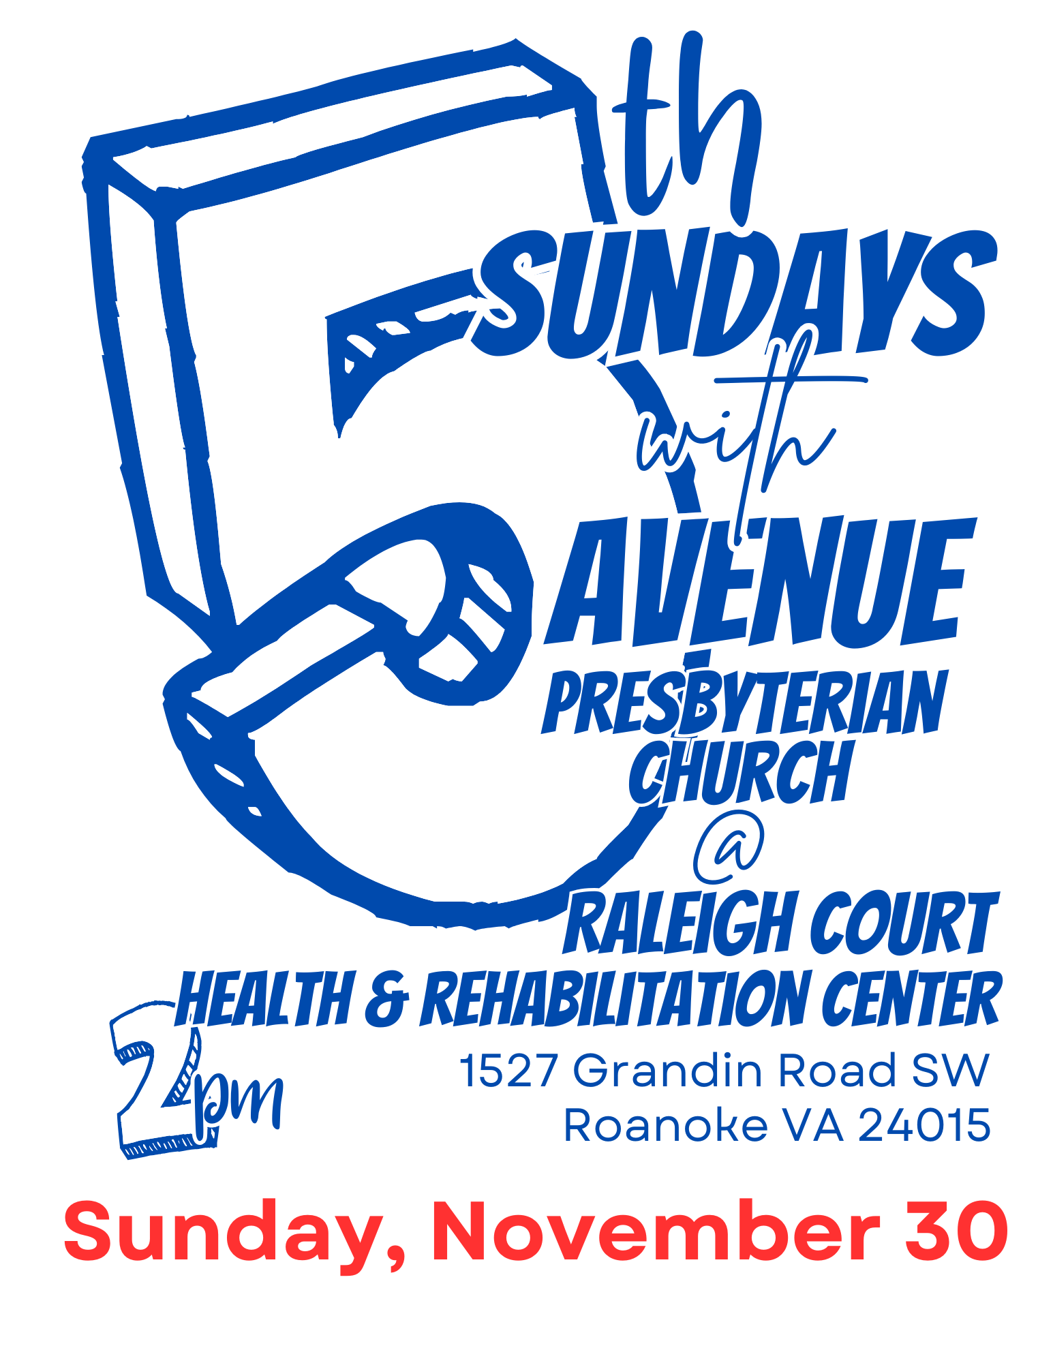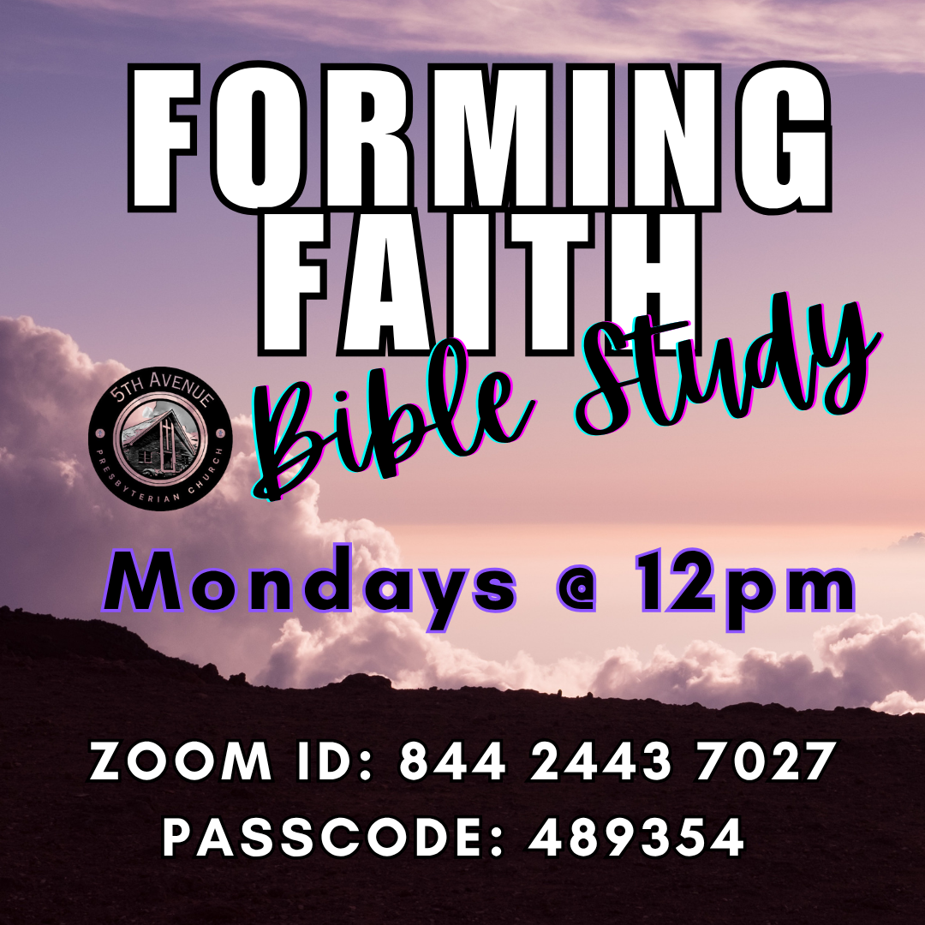
***
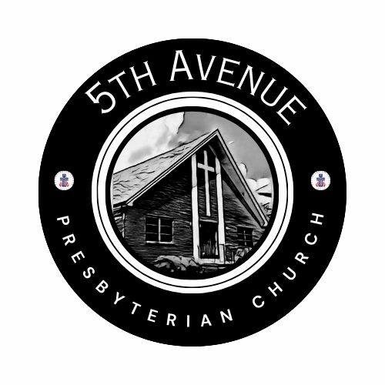

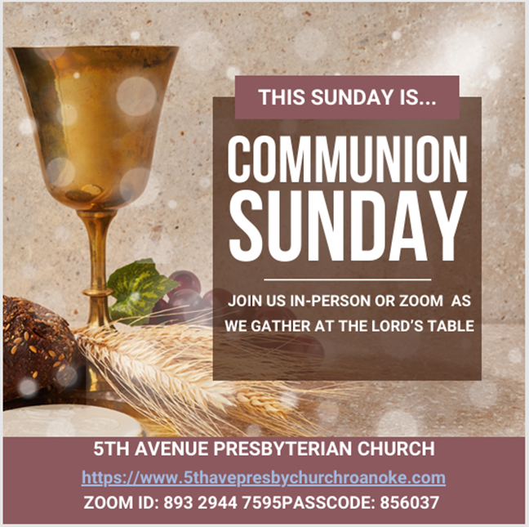
Sunday, November 2, 2025
We count it a joy that you would share with us today!
May the Lord bless you and keep you,
May the face of the Lord shine upon you and be gracious to you,
May the Lord turn to you and give you peace…

Prayers of the People
The Lord’s Prayer Our Father, who art in heaven, hallowed be thy name, the kingdom come, thy will be done, on earth as it is in heaven. Give us this day our daily bread and forgive us our debts as we forgive our debtors. Lead us not into temptation, but deliver us from evil, for thine is the kingdom and the power and the glory forever. AMEN.
Gloria Patri … Rev. Ellen Woodworth
Blessed Break (Let us greet one another in the name of Jesus)
We Share God’s Word
Scripture … Luke 19: 1-10 … Michael Blankenship
Reflect in Song … Avery Bolden
Message … Even Zacchaeus, Even Me … Rev. Vernie L. Bolden, Jr
We Respond
Respond in Song … Joyce Bolden

INVITATION TO THE TABLE
Meditation

The Bread and Cup (Let Us Break Bread … led by Rev. Ellen Woodworth)

Prayer of Thanksgiving
Affirm Our Faith (1 John 3: 5-10) ⁵ This is the message we have heard from the Lord and declare to you: God is light; in the Lord there is no darkness at all. ⁶ If we claim to have fellowship with God, yet walk in the darkness, we lie and do not live out the truth. ⁷ But if we walk in the light, as the Lord is in the light, we have fellowship with one another, and the blood of Jesus, God’s Son, purifies us from all sin. ⁸ If we claim to be without sin, we deceive ourselves and the truth is not in us. ⁹ If we confess our sins, The Lord is faithful and just and will forgive us our sins and purify us from all unrighteousness. ¹⁰ If we claim we have not sinned, we make God out to be a liar, and the word is not in us.
We Tell the Good News

Go in Peace … Rev. Ellen Woodworth

Benediction … Rev. Vernie L. Bolden, Jr

Fifth Avenue Presbyterian Church
Sunday, November 2, 2025
***
We Gather
Musical Prelude … Avery Bolden (2)
Scripture Reading … Psalm 32: 1-2, 6-7 … Nickey Wright
Blessed is the one whose transgressions are forgiven, whose sins are covered. ² Blessed is the one whose sin the Lord does not count against them and in whose spirit is no deceit… ⁶ Therefore let all the faithful pray to you while you may be found; surely the rising of the mighty waters will not reach them. ⁷ You are my hiding place; you will protect me from trouble and surround me with songs of deliverance.

Greetings/Call to Worship … Rev. Bob Fiedler
CALL: Come, Holy Spirit, come RESPONSE: Come to comfort us in our suffering
CALL: Come to cheer us in our sorrow RESPONSE: Come to encourage us in our failings
CALL: Come to persuade us in our doubting RESPONSE: Come to exhort us in our waning zeal
CALL: Come to urge us forward in following Christ’s truth RESPONSE: O Lord, as we worship you, renew our strength and fill us with your hope
TOGETHER: Thank you, Hallelujah and AMEN.

We Call Upon the Lord

Invitation in Song … Joyce Bolden

Call to Confession (from C.A. Riley) … Rev. Dusty Fiedler

Here we are dangling one another from the precipice without care or concern for our collective fate. We have lost sight of our own faces, risking our humanity in favor of supremacy. Guide us away from the edge of our undoing. Show us what it means to be people of deep and abiding reverence for the beauty and connectedness of us. Remind us that we don’t need to exalt ourselves over any other of our siblings in humanity in order to be worthy of dignity. May any honor we have withheld from one another be doubled with the reparation of forgiveness. AMEN.

Silent Confession
Assurance of Pardon
Let us find hope in the deep breath of our prayers…
INHALE: we honor this breath; EXHALE: we behold the beauty
INHALE: I can have more; EXHALE: I claim more
INHALE: this flesh is sacred; EXHALE: I am loved and forgiven by God in Christ. AMEN.

