
Fifth Avenue Presbyterian Church
301 Patton Avenue NW, Roanoke VA 24016
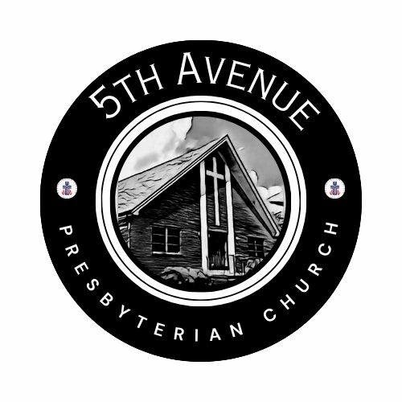
Third Sunday of Advent
Sunday, December 14, 2025
We count it a joy that you would share with us today!
May the Lord bless you and keep you,
May the face of the Lord shine upon you and be gracious to you,
May the Lord turn to you and give you peace…

Matthew 11: 1-6
11 After Jesus had finished instructing his twelve disciples, he went on from there to teach and preach in the towns of Galilee.
² When John, who was in prison, heard about the deeds of the Messiah, he sent his disciples ³ to ask him, “Are you the one who is to come, or should we expect someone else?”
⁴ Jesus replied, “Go back and report to John what you hear and see: ⁵ The blind receive sight, the lame walk, those who have leprosy are cleansed, the deaf hear, the dead are raised, and the good news is proclaimed to the poor. ⁶ Blessed is anyone who does not stumble on account of me.”
Our Prayer List
Jon Barton, Rhonda Hale, Jim Slaughter, Joe Loving, Jr, Thom Witting, Gabriela Rangel, Greg Beliveau, Geri Tankersly, Lucy Glymph, Jawaad Saunders, Virginia Robinson

SEASON of ADVENT: SUNDAY, NOVEMBER 30 – WEDNESDAY, DECEMBER 24

SESSION MEETING: TODAY, SUNDAY, DECEMBER 14: following the worship service

BLUE NIGHT WORSHIP:
SUNDAY, DECEMBER 18 @ 6pm
In-person and ZOOM ID: 832 9678 1799 Passcode: 128626

CHRISTMAS BRUNCH: SATURDAY, DECEMBER 20 @ 12pm
Contact Lisa Robinson for further details

FORMING FAITH BIBLE STUDY:
Mondays @ 12pm: Zoom ID: 844 2443 7027 Passcode: 489354

REMINDER: 5th Avenue safely and securely accepts gifts of offering and giving through mail, in-person, or our website: https://www.5thavepresbychurchroanoke.com

Fifth Avenue Presbyterian Church, 301 Patton Avenue NW, Roanoke VA 24016 https://www.5thavepresbychurchroanoke.com ZOOM ID: 893 2944 7595 PASSCODE: 856037

Fifth Avenue Presbyterian Church
Sunday, December 14, 2025
We Gather

Musical Prelude … Kimari Spangler (2)
Scripture Reading … Psalm 146: 5-10 … Tara Howard
Blessed are those whose help is the God of Jacob, whose hope is in the Lord their God. ⁶ The Lord is the Maker of heaven and earth, the sea, and everything in them— the Lord remains faithful forever. ⁷ The upholds the cause of the oppressed and gives food to the hungry. The Lord sets prisoners free, ⁸ the Lord gives sight to the blind, the Lord lifts up those who are bowed down, the Lord loves the righteous. ⁹ The Lord watches over the foreigner and sustains the fatherless and the widow but frustrates the ways of the wicked. ¹⁰ The Lord reigns forever, your God, O Zion, for all generations. Praise the Lord.

Greetings/Call to Worship (from Isaiah 61) … Nickey Wright This is the season of holy waiting. We wait for the One whose word can set captives free.
We watch for the day when all who mourn will know gladness and praise.
We wait while the dawning light appears on the horizon.
Come let us walk in the light of God! AMEN.

We Call Upon the Lord

Invitation in Music … Kimari Spangler

Prayers of the People … Rev. Ellen Woodworth
The Lord’s Prayer Our Father, who art in heaven, hallowed be thy name, the kingdom come, thy will be done, on earth as it is in heaven. Give us this day our daily bread and forgive us our debts as we forgive our debtors. Lead us not into temptation, but deliver us from evil, for thine is the kingdom and the power and the glory forever. AMEN.
Gloria Patri … Rev. Ellen Woodworth
SEASON of ADVENT

Blessed Break (Let us greet one another in the name of Jesus)
We Share God’s Word
Scripture … Matthew 11: 1-6 … Cathy Keith
Reflect in Music … Rev. Ellen Woodworth
Message … See and Hear … Rev. Vernie L. Bolden, Jr
We Respond
Respond in Song … Joyce Bolden

Celebration of Giving

Giving Prayer O Lord, we have come with our hearts open to you, seeking your healing and transforming love, yet as our world cries for justice for all people, we still clamor for our own selfish ways. O Lord because you have richly poured gifts of love, peace, hope, and joy into our lives; let us receive this offering as a reminder to live into your high expectations. AMEN.

Affirm Our Faith (Matthew 1: 20-24) ²⁰ But after he had considered this, an angel of the Lord appeared to him in a dream and said, “Joseph son of David, do not be afraid to take Mary home as your wife, because what is conceived in her is from the Holy Spirit. ²¹ She will give birth to a son, and you are to give him the name Jesus, because he will save his people from their sins.” ²² All this took place to fulfill what the Lord had said through the prophet: ²³ “The virgin will conceive and give birth to a son, and they will call him Immanuel” (which means “God with us”). ²⁴ When Joseph woke up, he did what the angel of the Lord had commanded him and took Mary home as his wife.
We Tell the Good News

Go in Peace … Rev. Ellen Woodworth

Benediction … LIGHTING of the CHRISTMAS TREE

